11.1.3 Editors - Compositor Editor - Header - Select Menu
Select menu 1
All 1
None 1
Inverse 1
Linked From 1
Linked To 1
Grouped 1
Grouped Extend 1
Activate same type previous 2
Activate same type next 2
Find Node 2

Select menu

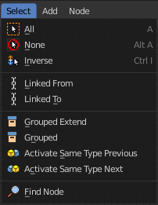
Here you will find the select functionality.

All
Select everything.

None
Select nothing.

Inverse
Invert the current selection.

Linked From
Select the nodes that are linked from the currently selected nodes. The nodes before in the hierarchy.

Linked To
Select the nodes that are linked to the currently selected nodes. The nodes behind in the hierarchy.

Grouped
Select grouped nodes.

Grouped Extend
Select grouped nodes, and extend from the current selection.

Activate same type previous
Activate same node type before the current selection, step by step.

Activate same type next
Activate same node type after the current selection, step by step.

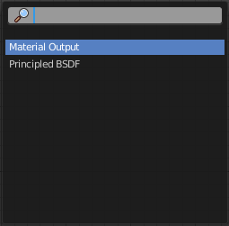
Find Node
This button will open a search dialog where you can search for node types and select them in the current hierarchy.

